China Production Rolling Restart



Document Reference Number – L3-271/2.xxx

**Version 0.1 D**

[](https://spo.mcd.com/sites/corp_itr_eas/team/eCP/)

**Document Control Record**

|  |  |
| --- | --- |
| Title |  |
| Version | 0.1 |
| Author | Aman Shrivastava |
| Approver | Ajay Garipally |
| Owner | DSS Middleware |
| Prepared By | Aman Shrivastava |
| Category | Middleware |
| Date Of Creation | 08/01/2018 |

**Issue and Amendments Record**

|  |  |  |  |  |  |
| --- | --- | --- | --- | --- | --- |
| Version | Revise  Date | Revised  By | Review  Date | Reviewed  By | Comment/Function Requested |
| 0.1 |  |  |  |  | Initial draft version |

**Table of Content**

Purpose of the Document 4

Basic Information/Prerequisites 4

Troubleshooting 4-6

Step 1: - Go on the path D:\ChinaMW and Add key CNNorth into Pageant by double clicking it: 4

Step 2: - Go to the mtputty application in the same path and after mtputty is open click on Server ..........5

Step 3: - After clicking on Server tab click on Import Tree Option and Import the latest modified tree .....6

Step 4:- After Importing the tree all the servers for Customer, Offer, Order, Gateway and Elastic Search are shown on the left hand side of mtputty application. You can open any server by double clicking the server on the left hand side .............................................................................................................................7

Step 5: - After Opening the server say Customer 1, you will be presented with a screen like this ..............8

Step 6: - You have to have root permission before doing anything inside any server. Therefore we will use command ‘sudo su - ’ ................................................................................................................................9

Step 7: - - Use command “ps –ef | grep gateway” to see if the process is running or not before the rolling restart ..............................................................................................................................................................10

Step 8: - Use command “service gateway stop” to stop the gateway service ...........................................11

Step 9: - Use command “ps –ef| grep gateway” to see that the gateway service has stopped or not .....11

Step 10: - Use command “service gateway start” after confirming that gateway service has stopped …11

Step 11: - Use command “ps –ef| grep gateway” to see that the gateway service has started or not …….11

Step 12: - For confirmation we have to see inside mule_ee.log under path /app/gateway/logs .................11

Step 13: - Use command “tail -f /app/gateway/logs/mule_ee.log” and see if you are getting “DEPLOYED”……………………………………………………………………………………………………………………………………………...12

Step 14: - Use command “ctrl + C” and it will get you to prompt ……………………………………………………………..12

Step 15: - Use command “exit” and it logout of the server ..........................................................................12

# Purpose of the Document

1. This document can be used for Rolling Restart of China Production Servers.

# Basic Information/Prerequisites

1. The activity is performed on Bastion Host - 10.1.231.205 therefore you need access for this bastion hos.

# Troubleshooting

## Step 1: -Go on the path D:\ChinaMW and Add key CNNorth into Pageant by double clicking it:

## 

## Step 2: - Go to the mtputty application in the same path and after mtputty is open click on Server:

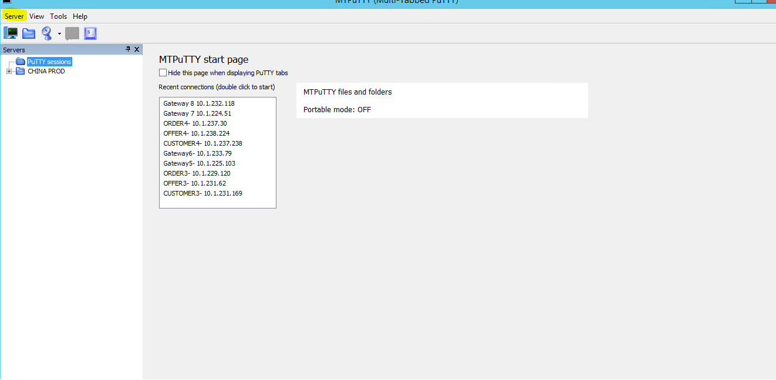

## Step 3: - After clicking on Server tab click on Import Tree Option and Import the latest modified tree :

## 

## 

## Step 4: - After Importing the tree all the servers for Customer, Offer, Order, Gateway and Elastic Search are shown on the left hand side of mtputty application. You can open any server by double clicking the server on the left hand side :

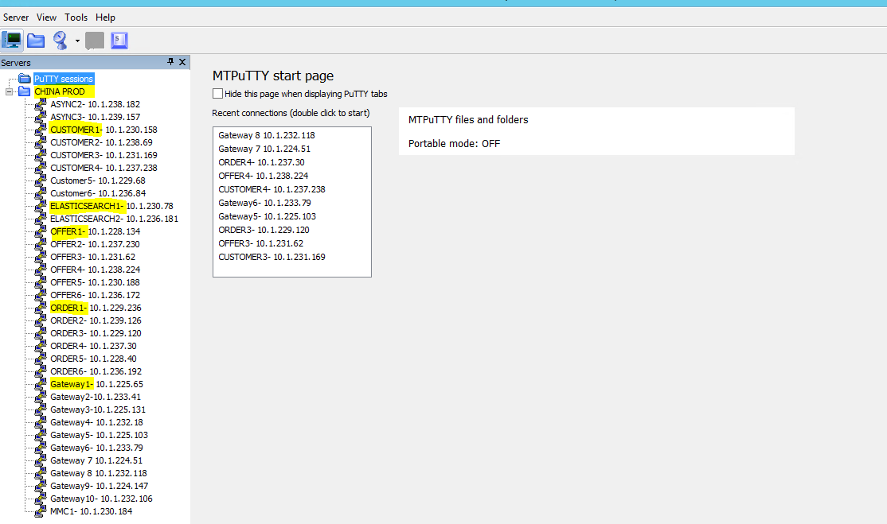

## Step 5: - After Opening the server say Customer 1, you will be presented with a screen like this :

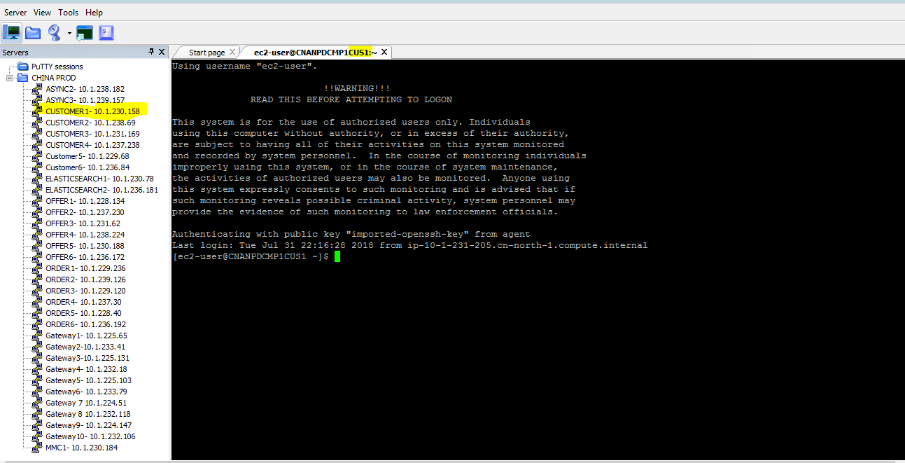

**Note** : For rolling restart of china production servers we have to make batches of servers where we restart only one batch of servers at a time:-

Say take Batch 1:- Customer 1, Order 1, Offer 1 and Gateway 1

Batch 2:- Customer 2, Order 2, Offer 2 and Gateway 2 and so on.

The reason for making the batches is that if we are restarting one batch and failure occurs our GMA will still be up and running because other servers will take care for servers that are down due to restart.

We will go for restart of another Batch if and only if the previous batch is up and running.

Also, we cannot make a Batch say :- Customer 1, Customer 2, Customer 3 and Customer 4 Because it leads to an outage of GMA, this has to be very specifically kept in mind.

## Step 6: - You have to have root permission before doing anything inside any server. Therefore we will use command ‘sudo su - ’ :

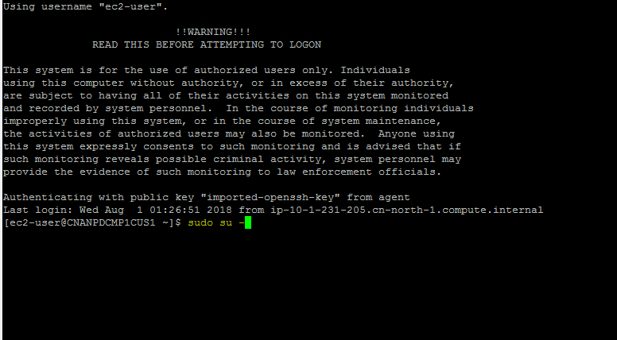

## Step 7: - Use command “ps –ef | grep gateway” to see if the process is running or not before the rolling restart :

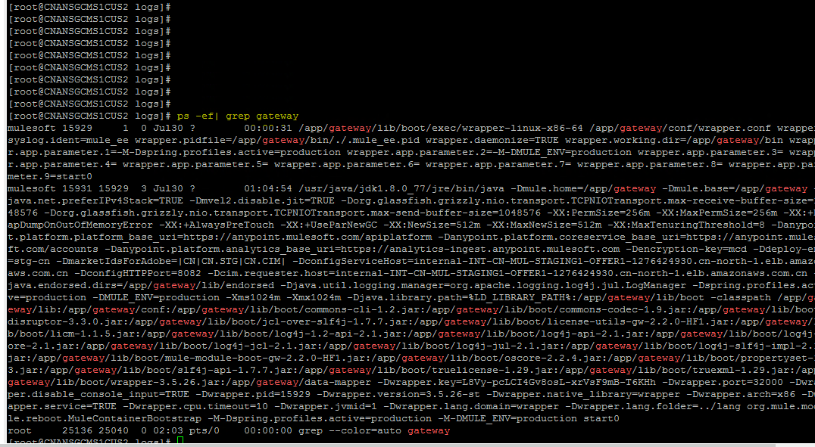

**Note :-** If the process is running we can go for the rolling restart and if the process can’t be seen as running we have to check for the issue inside the logs in the path cd /app/gateway/logs .

## Step 8: - Use command “service gateway stop” to stop the gateway service :-

## Step 9: - Use command “ps –ef| grep gateway” to see that the gateway service has stopped or not :-

## Step 10: - Use command “service gateway start” after confirming that gateway service has stopped :-

## Step 11: - Use command “ps –ef| grep gateway” to see that the gateway service has started or not :-

## Step 12: - For confirmation we have to see inside mule_ee.log under path /app/gateway/logs :-

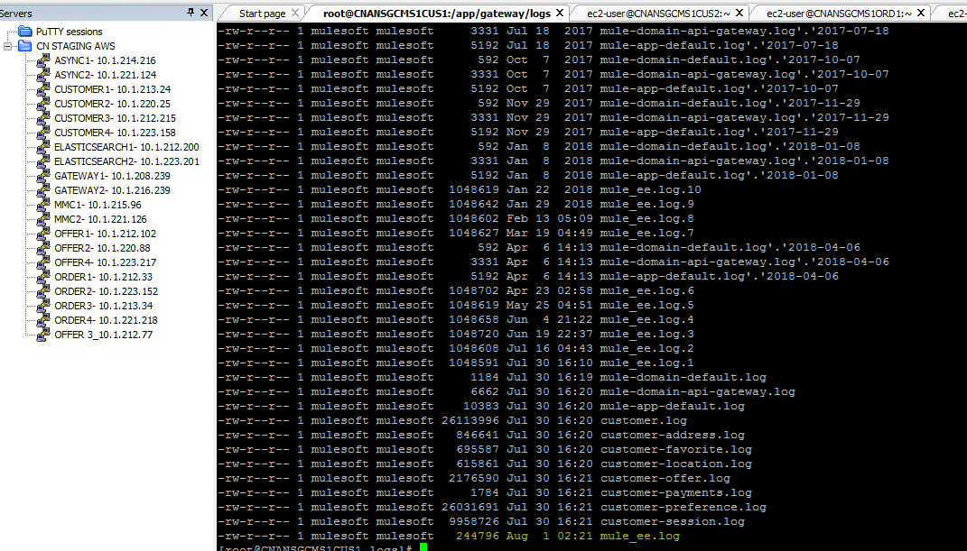

## Step 13 : -Use command “tail -f /app/gateway/logs/mule_ee.log” and see if you are getting “DEPLOYED”:-

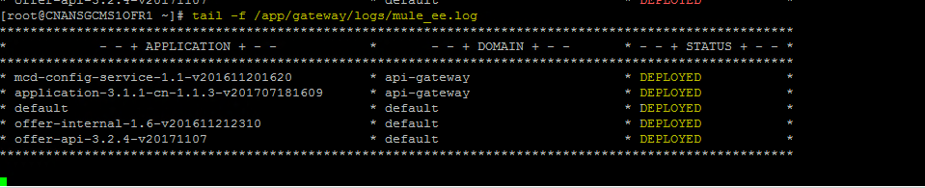

## Step 14 : -Use command “ctrl + C” and it will get you to prompt:-

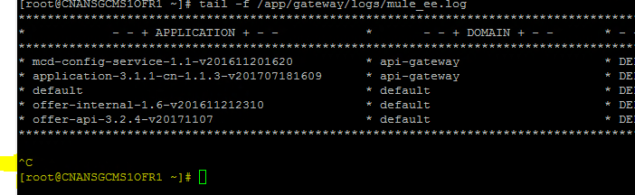

## Step 15 : -Use command “exit” and it logout of the server:-

